**W5-S2** PRACTICE

*CSS GRID LAYOUT*

## *At the end of this practice, you should be able to…*

* Identify the best **CSS grid approach** in different use cases
* From mockups to CSS grid layout

## *How to work?*

* Download **the start code** from the LMS
* Open the folder in VS Code

## *How to submit?*

* **Push** your final codeon **your GitHub repository**
* Then **attach the GitHub path** to the MS Team assignment and **turn it in**

## *Are you lost?*

*You can read the following documentation to be ready for this practice:*

* [Guide - WC3 School](https://www.w3schools.com/css/css_grid.asp)
* [Read our amazing book!](https://developer.mozilla.org/en-US/docs/Web/CSS/CSS_grid_layout)
* [Learn CSS Grid in 20 minutes](https://www.youtube.com/watch?v=9zBsdzdE4sM&ab_channel=WebDevSimplified) !
* [Check the Grid handout!](https://css-tricks.com/snippets/css/complete-guide-grid/)

# EXERCISE 1: The Basics!

* Start code is provided for this exercise!*

Using **grid layout**, build the layout pictured below.

*We want a gap of 20px between each item (horizontally and vertically)*

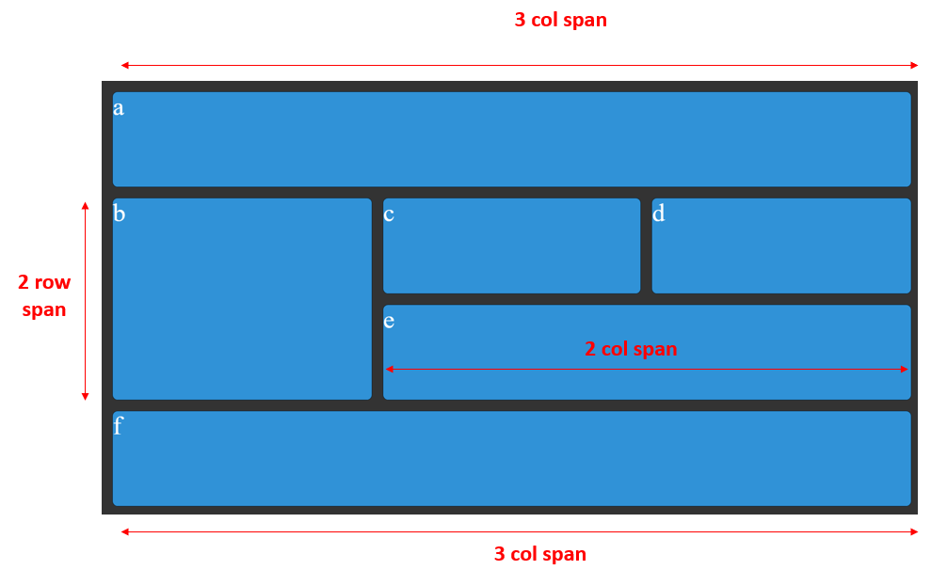

## *Are you lost?*

**TIP 1** - Here are the CSS properties involved in this exercise:

* grid-template-columns
* grid-template-rows
* grid-column
* grid-row
* display
* gap

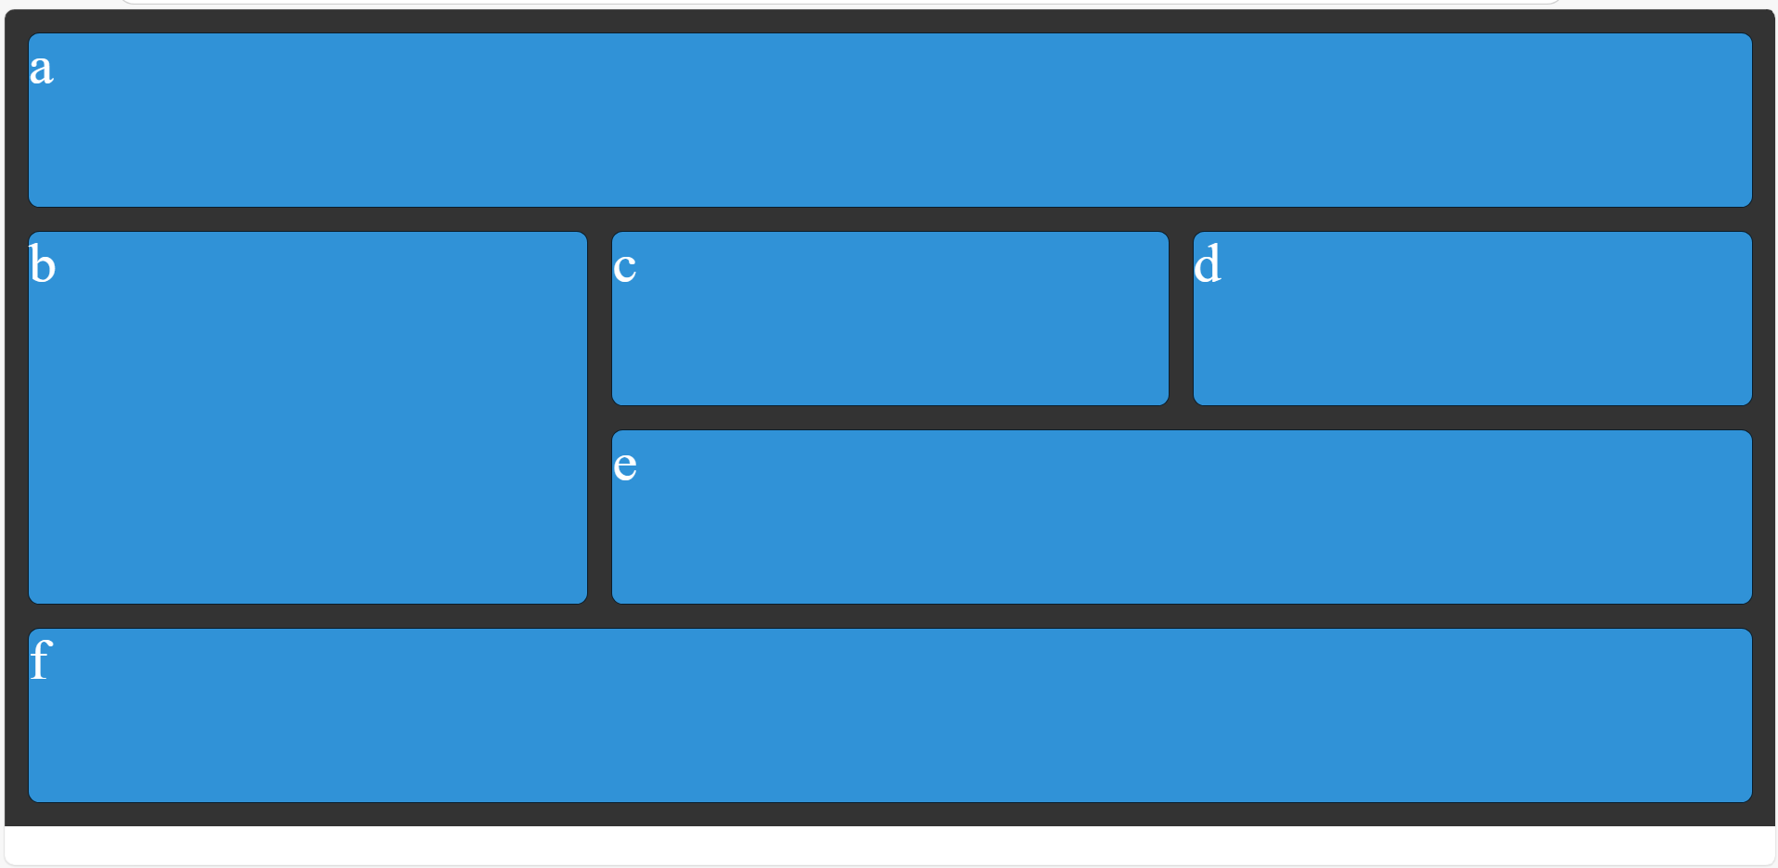

# EXERCISE 2: Nested Grids!

* Start code is provided for this exercise!*

Using **2 grid layouts**, build the layout pictured below.

* 1 grid to layout the **card container**
* 1 grid to layout the **card**

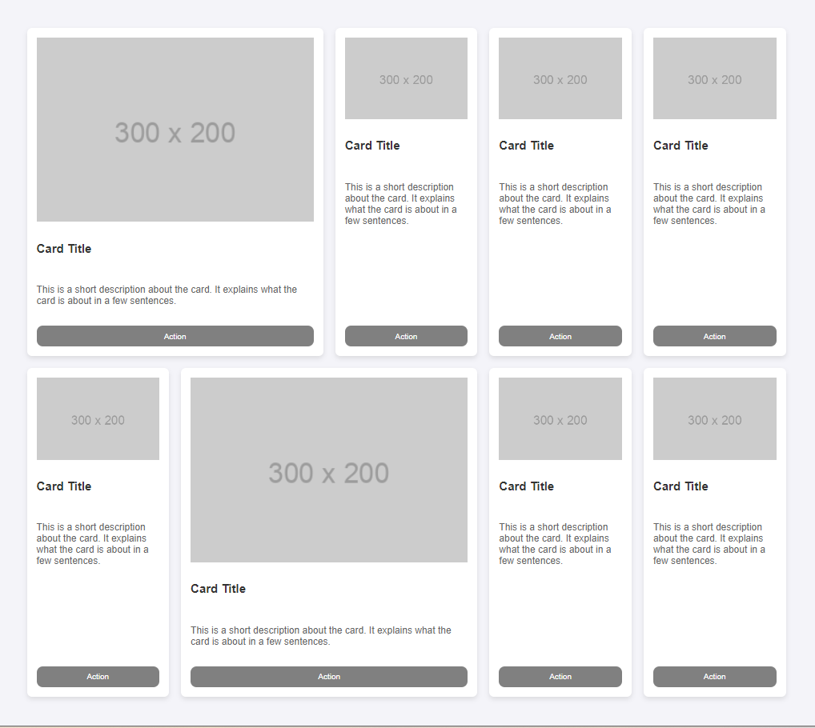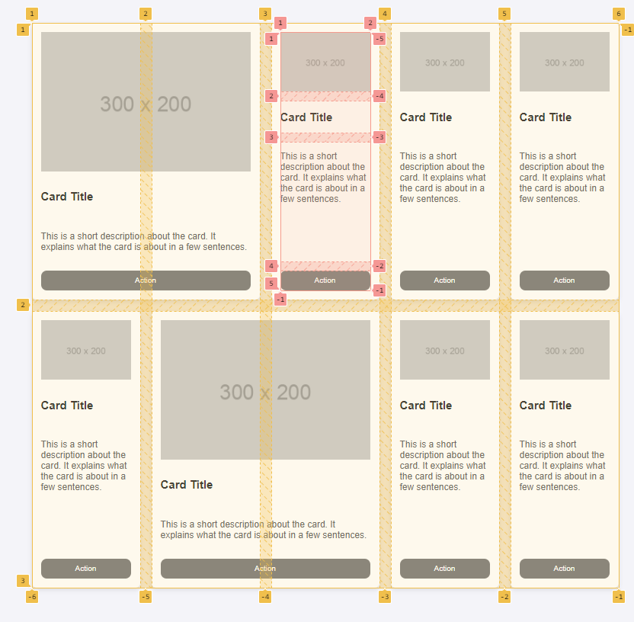

Notes

* Some cards span on 2 columns *(class span2)*
* Buttons should be vertically align with other button cards

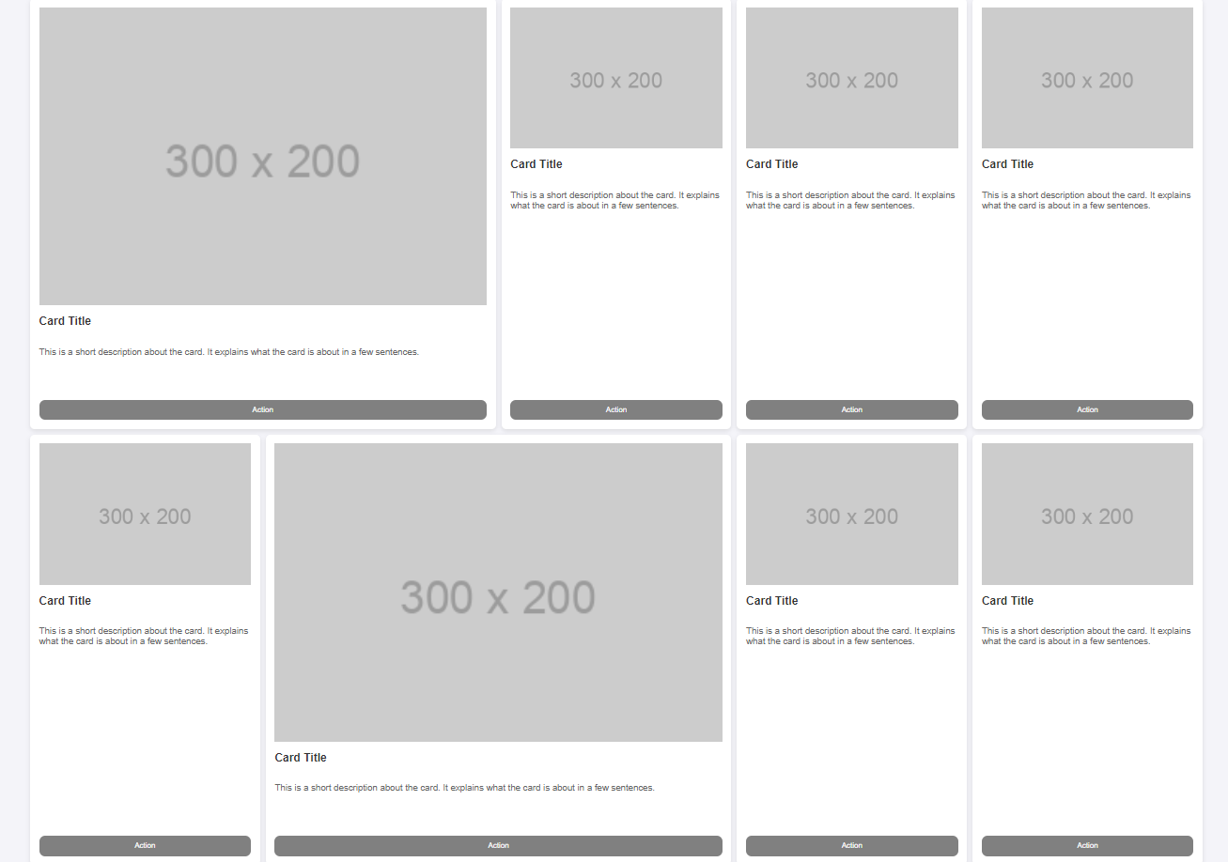

# EXERCISE 3: Responsiveness with grid layout

* Start code is provided for this exercise!*

We want to add a bit of responsiveness to our page.

*What is responsiveness and how to implement it with grid layout? Check out this link!*

<https://travishorn.com/responsive-grid-in-2-minutes-with-css-grid-layout-4842a41420fe>

The layout should display a single-column card on small screens (mobile) and a multi-column card layout on larger screens (tablet/desktop).

* Phone (by default) 1 column of cards
* Tablets (> 601px): 2 columns of cards
* Extra-large screens (> 1024px): 3 columns of cards

**TODO:** Add the needed media queries to change the grid layout, according to the device

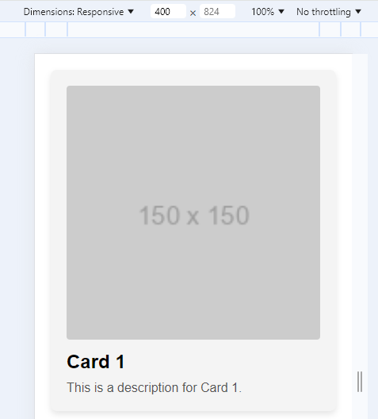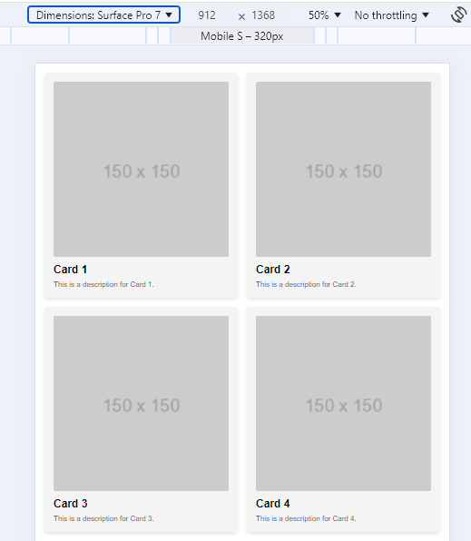

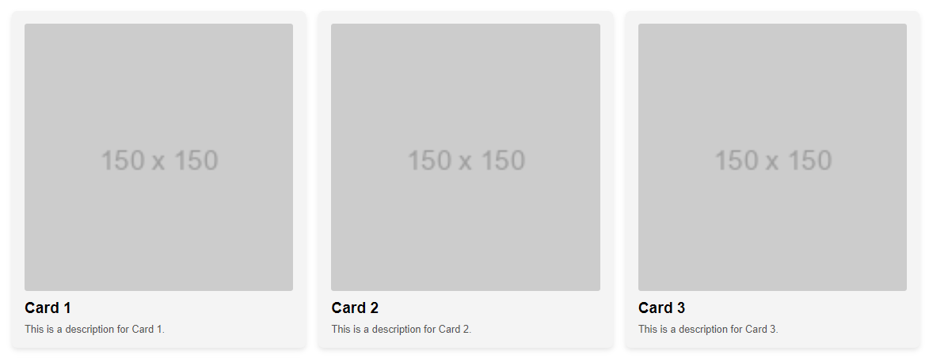

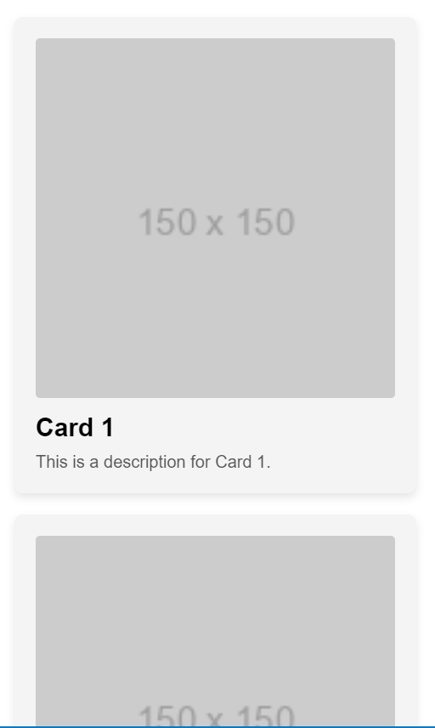

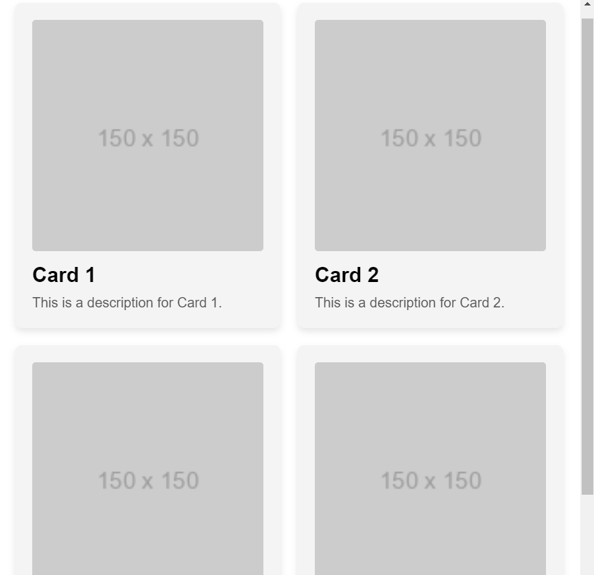

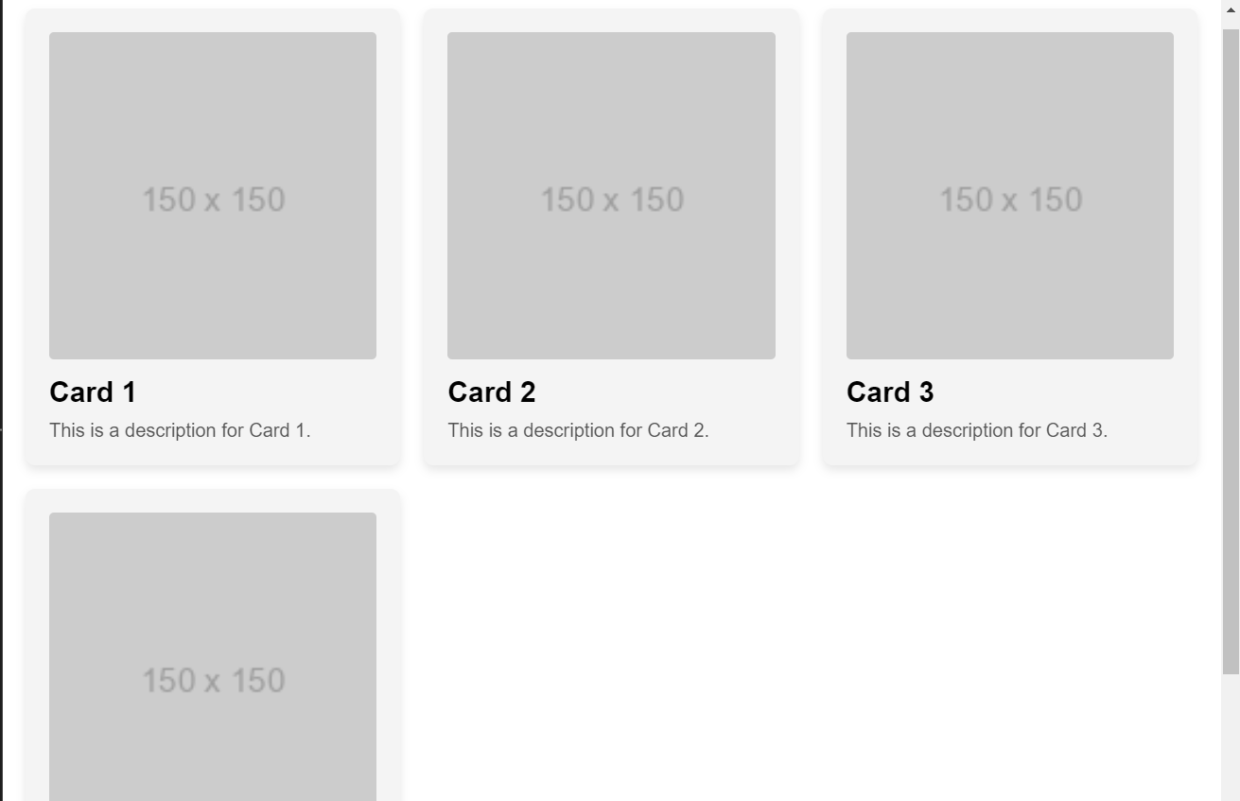

# EXERCISE 4

Create a responsive **dashboard layout** using either **CSS Flexbox or CSS Grid**. The dashboard should be visually appealing and functional, adapting to various screen sizes.

**This is a freestyle exercise, so you can express your creativity!!!**

*Note: we will ask you to explain your CSS strategy during the next review session. Be prepared to explain it.*

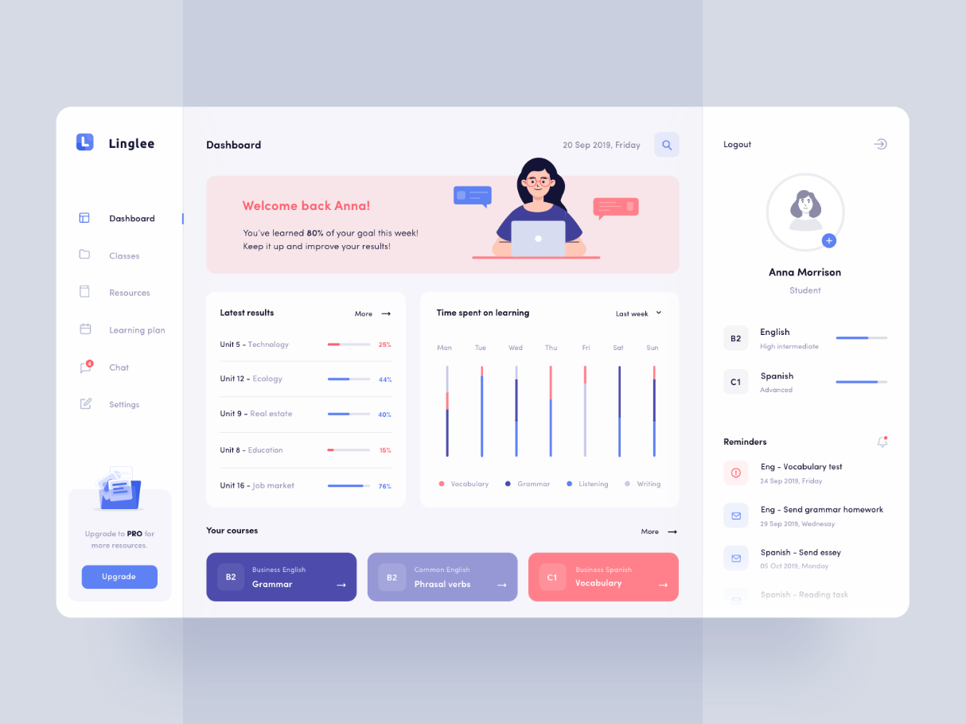

*Example of dashboard*